

AGRICULTURAL SPRAYING DRONE FOR FARMERS

# DEPARTMENT OF ELECTRONICS & COMMUNICATION ENGINEERING

**INNOVATE 2K23**

# Date: 19-04-2023

**A MINI PROJECT REPORT**

***Submitted by***

***BATCH MEMBERS***

|  |
| --- |
| **J.Augustin Raj(113320106005)** |
| **B.Mythreyan (113320106027)** |
| **ThannikulamMagesh(113320106043)** |

***BATCH GUIDE***

***DR.R.JOTHI CHITRA Project Guide Signature***

## MINI PROJECT REPORT (Around 15 Pages)

**Project Report should contain the following topics:**

* Front page
* Abstract
* Introduction
* Need for the Project
* Proposed Work
* Block Diagram
  + Functions of Each Block as Subheadings
  + Components Used
  + Hardware/Software Details
* Applications
* Conclusion
* Reference
* Photos of Project
* Photo of Team members with Guide

# ABSTRACT

* + The proposed project aims to address the challenges faced by farmers in conventional crop spraying methods and explore the potential of agricultural spraying drones. The project aims to implement an efficient and sustainable crop management strategy through the use of agricultural spraying drones, which will provide a more precise, cost-effective, and safe method of crop spraying.
  + The project will involve the development of a customized drone with a payload capacity suitable for crop spraying. The drone will be equipped with sensors and software to enable precise spraying of pesticides, herbicides, and other crop treatments. We will collaborate with local farmers to identify the most effective crop management practices and integrate these into the drone's software.
  + The project's expected outcomes are to increase the efficiency and effectiveness of crop spraying, reduce the use of harmful chemicals, decrease labor costs, and promote sustainable agriculture practices. The project will be evaluated by comparing the drone's performance to traditional crop spraying methods through metrics such as spraying time, spraying accuracy, and crop yield. This project will not only provide farmers with an innovative and efficient solution for crop management but also contribute to the sustainable development of agriculture in the region. We anticipate that the success of this project will attract interest from other farming communities, and the project can be scaled up to a larger area in the future.

# INTRODUCTION:

The Indian Agricultural sector is the most important sector as it amounts to a staggering 18% of India’s Gross Domestic Product (GDP) and also provides employment to 50% of the national human workforce

In India, there are over 35 drone start-ups that are working to raise the technological standards and reduce the prices of agricultural drones. This project aims to develop Unmanned Aerial Vehicle (UAV) for overcoming this problem and also spay large amounts of pesticides within smaller interval of time using Octocopter.

An automated agriculture spraying drone is a type of unmanned aerial vehicle (UAV) that is designed to spray liquid pesticides, fertilizers, or herbicides over crops.

These drones are equipped with spraying systems that can accurately and efficiently apply the liquid payload to the crops. They use advanced sensors, GPS, and software to navigate autonomously and avoid obstacles while performing the spraying mission.

They can cover large areas quickly and efficiently, reduce labor costs,it can reduce the amount of chemical is to be used and accurately than manual spraying. UAV and its spraying mechanism using simple cost-effective equipment. The universal sprayer system is used to spray for both liquid and solid content

# NEED FOR THE PROJECT

## Increased efficiency:

Using an agricultural spraying drone can help farmers cover large areas of land much more quickly and efficiently than traditional manual spraying methods. This can lead to increased productivity and cost savings.

## Precision agriculture:

Drones equipped with advanced technologies can help farmers identify and target specific areas of crops that require spraying. This can help reduce waste and minimize the impact of chemicals on the environment.

## Labour shortage:

There is often a shortage of skilled labor in the agriculture industry. An agricultural spraying drone can help fill this gap, reducing the need for manual labor and freeing up workers for other tasks.

## Safety:

Spraying chemicals manually can be hazardous to the health of workers, particularly if they are exposed to the chemicals for extended periods of time. An agricultural spraying drone can help reduce this risk by spraying from a safe distance.

# PROPOSED WORK:

The drone would need to be equipped with an automated flight control system, which would allow it to fly autonomously along a pre-programmed route using GPS and other sensors.

The drone would need to be programmed with algorithms that can identify and target specific areas of crops that require spraying. This would involve integrating advanced technologies.

The drone will spary the pesticides and fertilizer in the programmed manner in which that the amount of pesticide and fertilizer want to be spray in the plants it has been calculated.

It will cause the large amount of pesticides and fertilizer are spray to the plant it been prohibited and the crops will grow in perfect manner.

The drone would need to be tested and validated to ensure that it is capable of accurately spraying crops while maintaining safe flight operations.

This would involve conducting flight tests in a controlled environment and collecting data on performance.

Once the drone has been developed and validated, it would need to be deployed in the field and supported by a team of operators who can monitor and maintain the drone.

# BLOCK DIAGRAM:

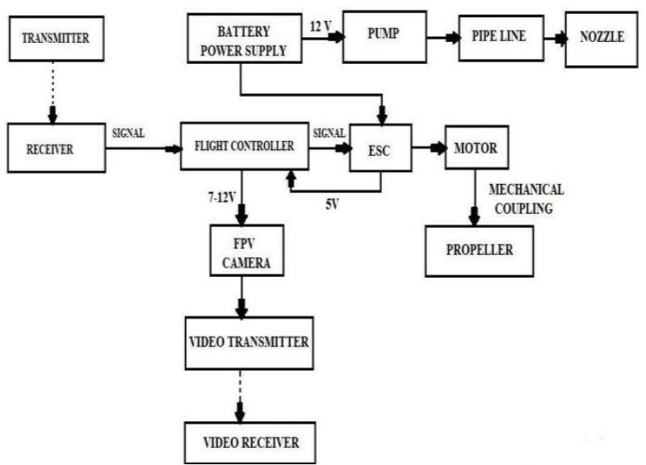

1. **MOTOR**:

Motor Outer runner DC motors in which there are no brushes, they have a permanent magnet. The RPM of the motor can be controlled by varying the input current. This motor propeller produces a maximum thrust of 4783 grams.

# Electronic Speed Controller(ESC)

It stands for Electronic Speed Controller and it is used to vary the Revolution Per Minute (RPM) of the motor. 60A rated ESC is used as per the motor and battery specifications.

# Flight Controller

The flight controller helps in the maneuvering operations and also it provides Auto level function. The accelerometer and gyroscope sensors in the Flight controller processes the signals from the receiver and gives the output to the ESC. The KK 2.1.5 Flight controller board can be used in the drone as it has inbuilt firmware.

# Radio Transmitter and Receiver

The Transmitter and receiver used are FlySky CT6B 2.4Ghz 6CH and FS-R6B respectively. This combination provides a range of about 1000 meters. This Transmitter and receiver provide upto 6 channel options

# Battery

The battery that can be used is a Li-Po battery of 22000mAh capacity and 22.2 V. In this battery six Li-Po cells are connected in series (6x3.7=22.2V)

# Pump and Nozzle

To pressurize the liquid a 12 V DC water pump can be used which has 2.5 L/min capacity can be used. Then the pressurized liquid enters the nozzle and gets sprayed.

The nozzle that can be used is a flat fan type for spraying the liquid. Four nozzles are connected with ducts and they are palace at 45cm distance between each other.

# Propeller

The propeller is of 24 inches length and has 7.2 inches pitch. It is made up of carbon fiber which possesses high strength to weight ratio when compared to the propellers made up of plastics.

**COMPONENTS USED:**

1. DC Brushless Motor
2. Electronic Speed Controller(ESC) 3.Flight Controller

4.Radio Transmitter and Receiver 5.Battery

6.Propeller 7.Drone Frame 8.Pump and Nozzle

# OUTPUT:

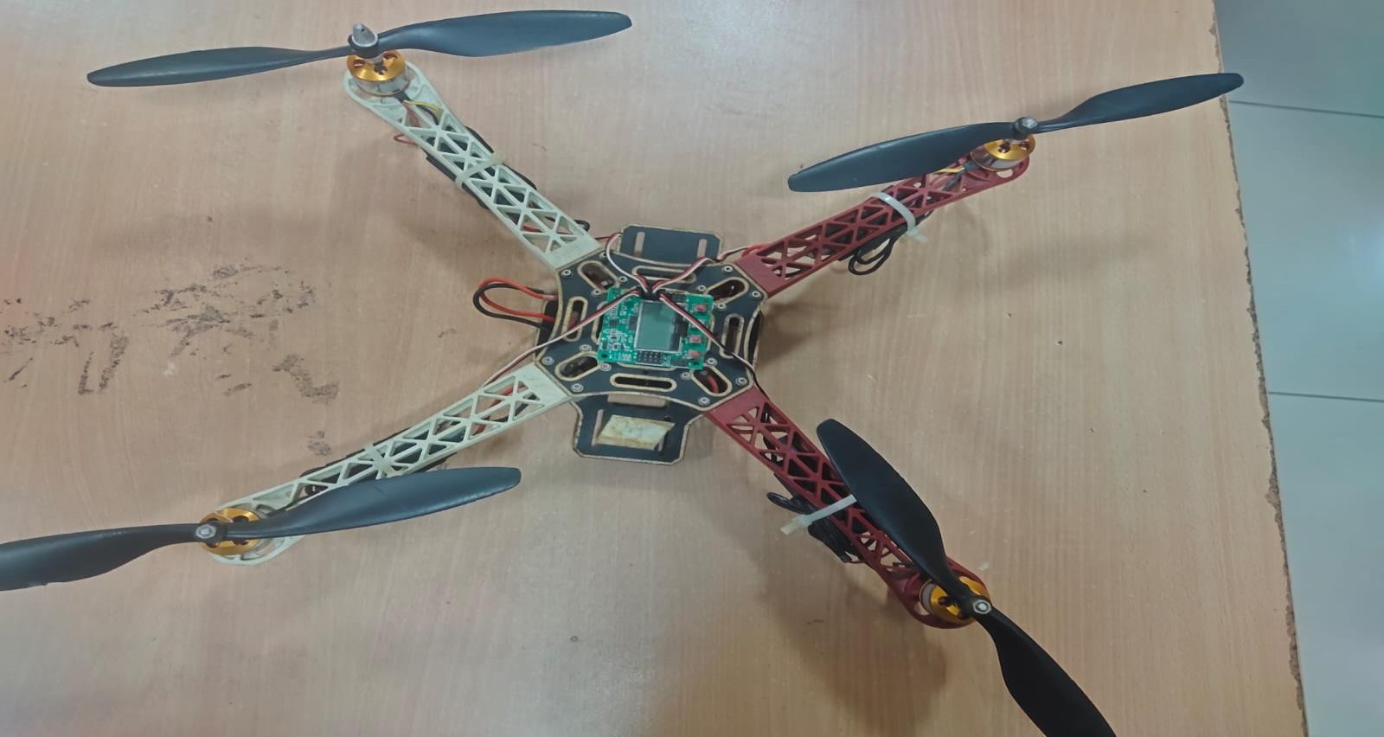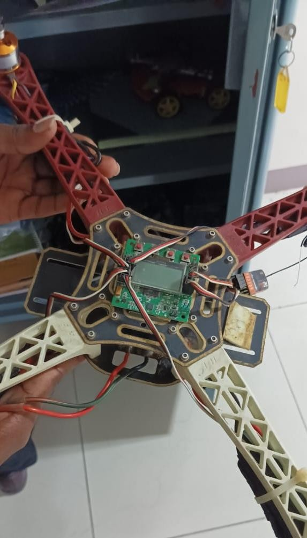

**HARDWARE / SOFTWARE DETAILS: HARDWARE DETAILS:**

1. DC Brushless Motor
2. Electronic Speed Controller(ESC) 3.Flight Controller

4.Radio Transmitter and Receiver 5.Battery

6.Propeller 7.Drone Frame 8.Pump and Nozzle

# 6.APPLICATION:

1. Automated agriculture spraying drones can cover large areas quickly and efficiently, reducing the time and labor required for crop spraying. This can lead to increased productivity and efficiency in agriculture.
2. By using automated agriculture spraying drones, farmers and workers can avoid direct exposure to potentially hazardous chemicals. This can improve safety and reduce health risks associated with manual spraying methods.
3. Automated agriculture spraying drones can apply liquid payloads more precisely and accurately than manual spraying methods.
4. Drones equipped with advanced sensors can collect data on crop health and growth patterns, providing farmers with valuable insights that can inform crop management decisions.

# CONCLUSION

A spraying mechanism for Agricultural purpose and for spraying disinfectants. This method of spraying pesticides on Agricultural fields reduces the number of labours, time, cost and the risk involved to the personnel involved in spraying the liquids. This drone can also be used in spraying disinfectant liquids over buildings, water bodies and highly populated area.

# REFERENCE

1. DJI Agras MG-1: This is a high-performance agricultural spraying drone that is designed for crop protection. It has a powerful propulsion system and can carry up to 10 kg of liquid payload. It uses advanced sensors and software to ensure accurate and efficient spraying. For more information**.**
2. Yamaha RMAX: The Yamaha RMAX is a popular agricultural spraying drone that is used by farmers around the world. It is equipped with a 2-stroke engine and can carry up to 28 liters of liquid payload. It also has advanced navigation and spraying systems that

ensure precise and effective application. DJI T16: The DJI T16 is a versatile agricultural spraying drone.

1. Kubota AGROBOT: The Kubota AGROBOT is a fully autonomous agricultural spraying drone that is designed to increase productivity and reduce costs. It uses advanced sensors and software to map the field and create a precise spraying plan. It can carry up to 10 liters of liquid payload.

## PHOTO OF TEAM MEMBERS WITH GUIDE:

